|  |  |  |  |  |  |
| --- | --- | --- | --- | --- | --- |
| **Document History** | | | | | |
| **Version** | **Date** | **Author** | **Section** | **Changes** |
| 1.0 | 10-07-2015 | Deepthi Shivakumar | All | Release 2 features |
| 1.1 | 30-09-2015 | Sameer Sulaiman | Integration section | Bazaar voice feature changes. |
| 1.2 | 1-10-2015 | Deepthi Shivakumar | Integration section | Bazaar voice feature changes. Added API details. |
| 1.3 | 12/12/2015 | Sameer Sulaiman | Integration section | Modified changes for 15.2 PI release. |
| 1.4 | 04/03/2016 | Sameer Sulaiman | Integration section | Modified changes for 16.2 PI release with Multiproduct Support. |

|  |  |
| --- | --- |
| **Author** | Deepthi Shivakumar, Sameer Sulaiman |
| **Approved by** | [Aravind.Gundumane@philips.com](mailto:Aravind.Gundumane@philips.com) |
| **Email Id** | Deepthi.Shivakumar @philips.com, Sameer.Sulaiman@philips.com |

Digital Care IOS Integration

1. INTRODUCTION 3

2. INTEGRATION 3

2.1 Cocoa pod Integration 3

2.2 Library Integration 3

2.3 Library versioning 4

2.4 Prerequisites 4

3. INITIALIZATION 5

3.1 Digital care Configuration 6

3.1.1.1 Main menu configuration 8

3.1.1.2 Product menu configuration 9

3.1.1.3 Social provider configuration 10

4. Vertical features customization 12

5. Navigation bar customization 14

6. Tagging 14

7. CustomNavigationBarUISupport 14

8. LOCALIZATION SUPPORT 13

9. FAQ 13

10. Notes 14

# INTRODUCTION

This document provides an overview of integration procedure for consumer care library in iOS mobile applications.

Digital care library provides set of standardized consumer care support features which can be used in all Philips apps.

# INTEGRATION

## Cocoa pod Integration

The easiest and preferred way to use these components is using Cocoapods (version 0.36.0 or newer). In your podfile, you have to add a source line for the Philips internal pod spec repository. So a minimal Podfile would look like this:

Source: <https://atlas.natlab.research.philips.com/stash/scm/ehpmat/cocoapod-specs.git>

pod PhilipsConsumerCare, '~> 4.0.2'

Please refer sample app to add dependent libraries.

Integrating application can get the Library, Include and Bundle files from the below path,

Source>DigitalCareLibrary > DCLibArtifacts

## Library Integration

1. Git source path : [http://pww.clscmgit.pic.philips.com:9000/scm/git/DigitalCare_iOS](http://ingbtcpic2lx253.blr.pin.philips.com:8080/scm/git/DigitalCare_iOS)

Branch: PI16.1

1. Check out the code from above path where in you can find sample app which depends on consumer care library’s .a file.
2. Consumer care needs other libraries to build which are as below
3. PhilipsAppTagging.a pod ‘PhilipsAppTagging’ , ‘~> 0.2’
4. liblocaleMatch.a pod ‘PhilipsLocalMatch’ , ‘~> 0.2’
5. PhilipsUIKit >= 3.1.0 pod ‘PhilipsUIKit’ , ‘~> 3.0’
6. PhilipsIconFont >= 1.1 pod ‘PhilipsIconFont’ , ‘~> 1.1’
7. AFNetworking (<https://github.com/AFNetworking/AFNetworking)> pod ‘AFNetworking’ , ‘~> 3.0’
8. MBProgressHUD (MBProgressHUD.h, .m - <https://github.com/jdg/MBProgressHUD)> pod ‘MBProgressHUD’ , ‘~> 0.9.2’
9. PRXLib (libPRXClient.a - http://pww.clscmgit.pic.philips.com:9000/scm/git/hor-prxclient-ios)

Please take the PI16.1 release branch for PRXLib and also available in pod ‘PhilipsPRXClient’, ‘~> 0.0.3’

1. ProductSelectionLib (libProductSelection.a - <http://pww.clscmgit.pic.philips.com:9000/scm/git/hor-productselection-ios)>
2. AdobeMobileLibrary.a

Please take the PI16.1 release branch for ProductSelectionLib and also available in pod ‘PhilipsProductSelection’, ‘~> 1.1.1’

Note:- Please make sure if ProductSelection is added via static library integrating app have to add the libProductSelection.a, ProductSelectionResources.bundle and header files available at GIT repo PI16.1 tagged version 1.1.1

Folder path -> hor-productselection-ios/Source/ProductSelection/Artifacts/

Please make sure all these are added to application’s build phase.

1. Please copy DigitalCareConfiguration.plist from library’s DigitalCareBundle.bundle to application’s folder and override the attributes.
2. Override the values in config file and define the features as per requirement.

## Library versioning

Library version can be obtained by using below API

[DCHandler getDCLibraryVersion];

## Prerequisites

1. Application need to know **CTN** number for each product used in app     Ex: HD8967/01 2.Along with sector and catalog. Example: **Sector**: B2C and **catalog**: CARE ( Mandatory for Consumer care )Most of the apps will have above sector and catalog.

Above information is used for backend services and mostly uses PRX system.  Hence Please provide valid and complete CTN number as input otherwise consumer care features are not functional as expected.

# INITIALIZATION

1. App can invoke the library using below API by importing “DCHandler.h”,

[DCHandler invokeDigitalCareWithParentController:self delegate:self withTransition:ANIMATIONSWIPERIGHT productModelSelection:hardcodedList andCompletionHandler:^(void){}]

Below animations are supported currently,

ANIMATIONSWIPERIGHT, ANIMATIONSWIPELEFT, ANIMATIONSWIPETOP, ANIMATIONSWIPEBOTTOM, NOANIMATION’

### b. PhilipsUIKit:-

The Multiproduct Selection component uses the PhilipsUIKit for the UI components.So the applications that are already using PhilipsUIKit need not do anything.Applications that are not using the PhilipsUIKit have to assign the theme, else it will use the default blue theme for MultiproductSelection.

Configuring the theme:



[PhilipsUIKit Documentation](http://sesvm-webserver.htce.nl.philips.com/PhilipsUIKit/ios/latest/Documentation/)

c. For supporting MultiproductSelection we have introduced new parameterName in the invoking method ‘**productModelSelection(PSHardcodedProductList*)hardcodedList’**. Vertical app has to set this parameter values before invoke method. This is applicable for single as well as multiple products and depends on the array size consumer care will launch the multiproductselection library in consumercare .

Apart from this Vertical must set the SECTOR and CATALOG values as mentioned in the below enum’s.

Catalog Types Available :-

DEFAULT_CATALOGTYPE,

CONSUMER_CATALOGTYPE,

NONCONSUMER_CATALOGTYPE,

CARE_CATALOGTYPE,

PROFESSIONAL_CATALOGTYPE,

LP_OEM_ATG_CATALOGTYPE,

LP_PROF_ATG_CATALOGTYPE,

HC_CATALOGTYPE,

HHSSHOP_CATALOGTYPE,

MOBILE_CATALOGTYPE,

EXTENDEDCONSENT_CATALOGTYPE

Sector Types Available:-

DEFAULT_SECTORTYPE,

B2C_SECTORTYPE,

B2B_LI_SECTORTYPE,

B2B_HC_SECTORTYPE

Ex:-

PSHardcodedProductList *hardcodedList = [[PSHardcodedProductList alloc] initWithArray:[NSArray arrayWithObjects:@"HX9371/04",@"HF3330/01",@"HP6581/03",@"HP8656/03",@"S9031/26",@"SCF693/17",@"SCF145/06",@"FC6168/62",@"GC9550/02",@"PR3743/00", nil]];

hardcodedList.catalog=CARE_CATALOGTYPE;

hardcodedList.sector=B2C_SECTORTYPE;

[DCHandler invokeDigitalCareWithParentController:self delegate:self withTransition:ANIMATIONSWIPERIGHT productModelSelection:hardcodedList andCompletionHandler:^(void) {

}];

Note: Please make sure that consumer product info class is removed , as we are getting the product information from PRX Server.

## Digital care Configuration

The application has to copy DigitalCareConfiguration.plist from library resource bundle and create one in app resource bundle by overriding the parameters present in it. The file contains the following,

1. UI resources like themes, styles, background colors and strings
2. Facebook and twitter Philips product page url.
3. App store id.An array is defined for defining main menu title, main menu icons, product menu title and social provider list. Each menu contains default features supported by Digital Care library. App can include only the required features by adding/deleting/modifying the array items.
4. Each title string in above arrays is expected to be a resource key and not the value.
5. ProductionEnvironment is added where in apps can mention whether it is production or test environment. This is applicable for all backend systems which we use.

#### Main menu configuration

**HamburgerMenuIcon**

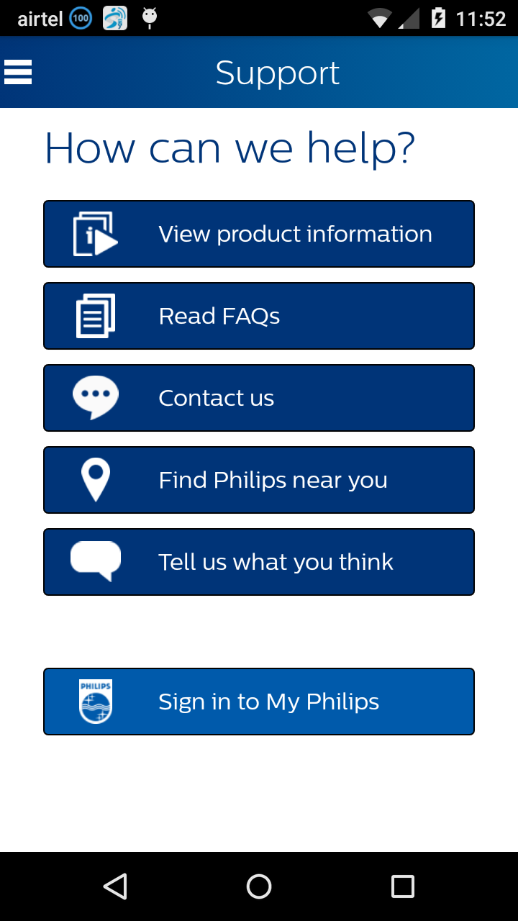

**RegisterButtonBackgroundColor**

**IconName under Main Menu**

**Localisedkey under Main Menu**

**ButtonTextColor**

**ScreenBackgroundColor**

**ButtonBackgroundColor**

**HeaderTextColor**

**NavigationBarTitleColor**

**NavigationBarStartColor**

**NavigationBarEndColor**

#### Product menu configuration

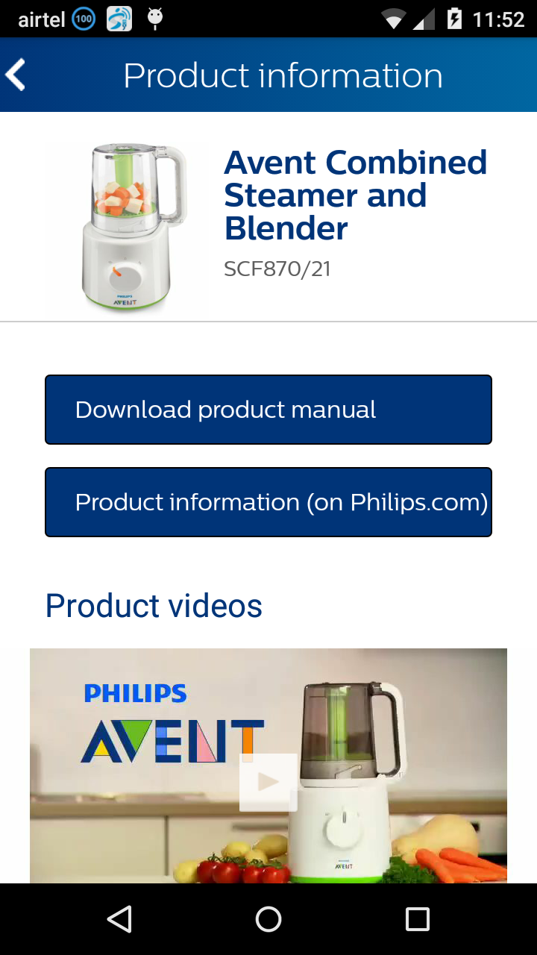

ProductMenu-> LocalizedKey

UINavigationbarbackbutton

#### Social provider configuration

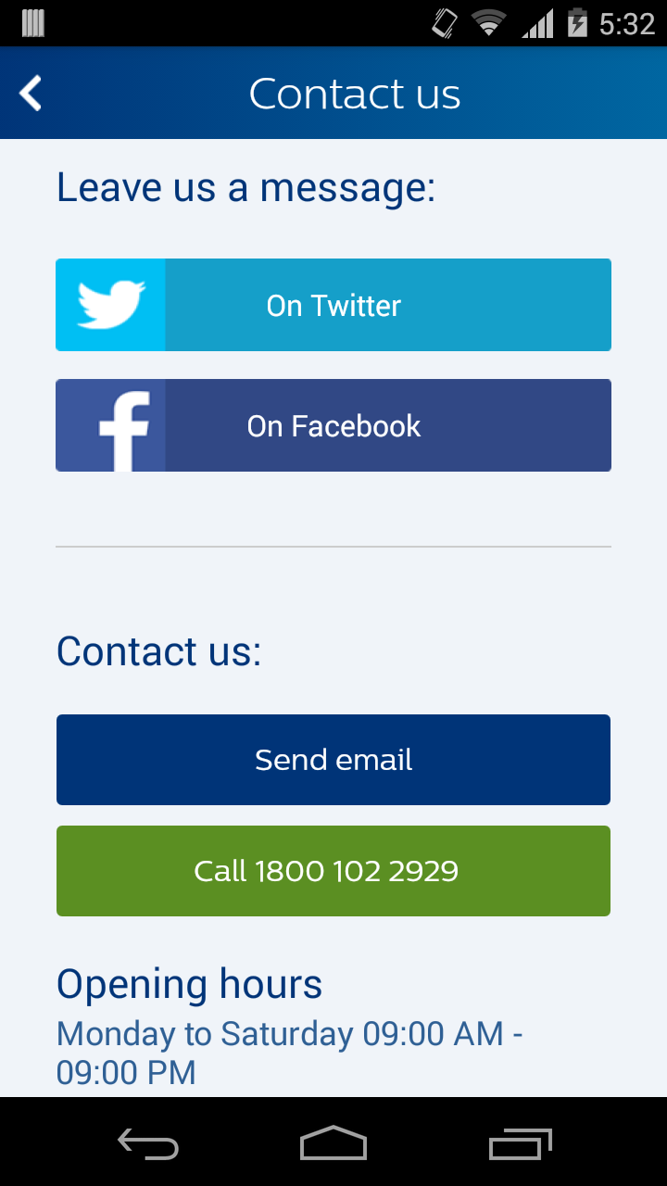

**SubHeaderTextColor**

**IconName under SocialListProviders**

**LocalisedKey under**

**SocialListProviders**

**NavigationBarBackButtonIcon**

# Vertical features customization

* 1. App can add its own button by passing valid string for button title and icon resource name in configuration file.
  2. Application has to set product information like product title, ctn, and category etc by overriding “DCConsumerProductInfoProtocol” class.
  3. Also application has to implement protocols like MainMenuDelegate,

ProductMenuDelegate, and SocialProviderDelegate.

1. MainMenuDelegate – Invoked on click of each button on support home page. This helps in configuring features on main/home page.
2. ProductMenuDelegate – Invoked on click of each button on product info page. This helps in configuring features on product info page.
3. SocialProviderDelegate – Invoked on click of each social provider buttons in Contact us page. This helps in configuring list of social list providers. CC by default supports Facebook and Twitter.
   1. App is required to implement all these to take control on app side for the

menu items which is added by verticals. For digital care menu item, library is supposed to take action and app should not ideally override this.

* 1. If app returns “true” then it means that app will take action on click of that

button and library will not perform anything in that case otherwise library will take action if app returns “false”.

Example : Air Fryer customization

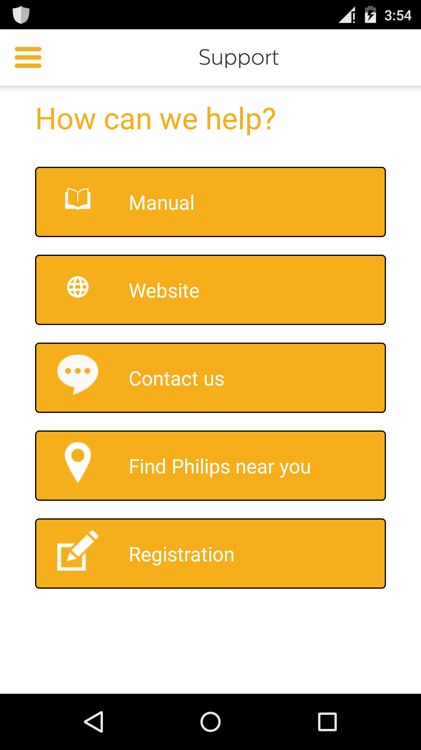

# Navigation bar customization

Here is how we customize navigation bar in consumer care module,

1. We allow customization of both Hamburger menu icon and back arrow button in navigation bar.
2. Projects which uses navigation bar will go for above option.
3. Projects where in navigation bar is not used, will  have to do the following
4. Replace hamburger menu icon with back arrow icon.
5. Set navigation bar background color same as screen background color.
6. Sets a boolean in config file which says hamburger menu title required as “False”, in this case navigation bar title will not be shown in consumer care.
7. On click of customized hamburger menu, a delegate is set(if HamburgerIconControlRequired = YES in config file) and in android it just navigates to previous activity/fragment.
8. Projects which uses spring board, replaces hamburger menu with spring board icon.
9. On invoking DigitalCare Library while passing the parentviewcontroller as parameter we are allowing if parentviewcontroller is having NavigationController or parentviewcontroller itself is a navigationcontroller the app will launch its navigation controller. This case no customization is required for DigitalCare library navigation bar.

# Tagging

Apps must provide app id or tracking identifier to consumer care component through this API

[DCHandler setAppIdForTagging:@“”];

Apps must provide previous pagename for tagging like below

[DCHandler setPreviousPageNameForTagging:@””];

Apps can also enable/disable tagging like below

[DCHandler setShouldTrackAnalytics:YES];

**If app enables tagging and appid is not set, then digital care library will throw runtime exception.**

# CustomNavigationBarUISupport

Apps which are using custom navigation bar facing any issue in top constraint (top getting moved up ) can set this api which return a float value.

[DCHandler setCCUITopConstraint:50.0];

If not it will take the default value 0.

# Localization support

|  |  |  |  |  |  |
| --- | --- | --- | --- | --- | --- |
| English | German | French (FR) | Simplified Chinese | Traditional Chinese | Portuguese (EU) |
| Russian | Arabic | Japanese | Dutch | Malay | Montenegrin |
| French-CA | Romanian | Spanish Mexican | Ukrainian | Portuguese (BR) | Serbian |
| Gaelic | Greek | Hebrew | Hindi | Finnish | Swedish |
| Italian | Polish | Spanish | Korean | Czech | English UK |
| Norwegian | Albanian | Bosnian | Bulgarian | Croatian | Estonian |
| Hungarian | Indonesian | Kazakh | Latvian | Lithuanian | Macedonian |
| Slovak | Slovenian | Spanish (AR) | Thai | Vietnamese | Danish |
| Farsi | Turkish |  |  |  |  |

# FAQ

**a.**   **How about customising fonts and sizes?**

We use Central Sans Font as per Philips design guidelines. Both fonts and sizes cannot be configured as of now.

**b.**   **Can we add our own buttons inside consumer care?**

Yes. However we have restricted this to main menu screen, product menu and list of social service providers list.

**c.**  **Does Consumer care support App Tagging?**

Yes. Please make sure you call enableTagging and provide apps ID. Please check sample app for more details. Unless App calls enableTagging () API tagging will not be enabled inside consumer care.

**d.**  **Where do I find my product information?**

Each business has to provide complete ctn number including slash

Ex: HD9240/90

With this please check below link which helps in finding out product tree information like category, sub category etc. please add relevant ctn number

a.  <http://www.philips.co.uk/prx/product/B2C/en_GB/CONSUMER/products/HD9240/90.summary>

b.  <http://nlvu077.gdc1.ce.philips.com:9080/repobrowser/catalogBrowser.jsp?catalogid=catalog_CL_CONSUMER&catalogType=CONSUMER&country=CL&language=es>

Please replace locale to check whether product data is available in corresponding countries.

**e.**   **Does Consumer care support multiple products?**

Yes, it supports multiple products from 16.1 release which has version 4.0.2

.

Currently app can send hardcoded list of products as input after which consumer care will take care of selection of product.

# Notes

1. Registration is developed as separate library project. App is expected to invoke registration library on click of registration button inside consumer care support page.
2. Integrating application has to add the list of custom font‘s which is used in the sample application for DigitalCareLibrary ,which is mentioned in the LibraryIntegrationSample app info.plist.
3. Please refer sample application for more details.
4. Consumer Care 4.0.2 version will give support from iOS 8 and greater.